

**Department of Computer Science & Engineering**

**B.Sc. in Computer Science & Engineering**

**Course Tittle:** Object Oriented Programming Laboratory

**Course Code:** CSE 216

**Submitted By**

**Name:** Hasmun Nahar Hasi

**ID:**0272130005101136

**Batch**: 58th

**Section:** B

**Submitted To**

**Debobrata Chakraborty**

**Lecturer**

**Department of CSE**

**City University**

Submission Date :12/09/2025

**LAB-01**

**Q-1: Print hello world.**

package q1;

public class Q1{

public static void main (String [] args) {

System.out.println("Hello World");

}

}

**Output:**

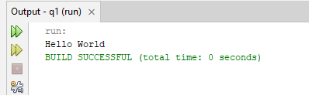

**Q-2: Print Employee details (Name, ID, Salary, Annual Salary).**

package q2;

public class Q2 {

public static void main (String [] args)

{

String name = "Hasi";

int id = 1136;

double salary = 30000;

double annualSalary = salary * 12;

System.out.println("Name: " + name);

System.out.println("ID: " + id);

System.out.println("Monthly Salary: " + salary);

System.out.println("Annual Salary: " + annualSalary);

}

}

**Output:**

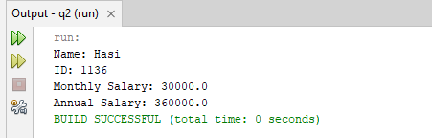

**Q-3: Swap two variables using a third variable.**

package q3;

public class Q3{

public static void main (String [] args) { int a = 10, b = 15, temp;

temp = a;

a = b;

b = temp;

System.out.println("a = " + a + ", b = " + b);

}

}

**Output:**

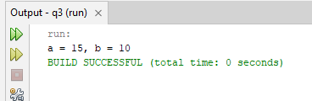

**Q-4: Swap two variables without using a third variable.**

package q4;

public class Q4{

public static void main (String [] args) { int a = 10, b = 15;

a = a + b; b = a - b; a = a - b;

System.out.println("a = " + a + ", b = " + b);

}

}

**Output:**

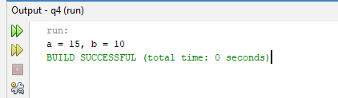

**LAB-02**

**Q-5: Swap two numbers using bitwise operation (XOR) in Java.**

package q5;

public class Q5{

public static void main (String [] args) { int a = 10, b = 20;

System.out.println("Before Swap: a = " + a + ", b = " + b); a = a ^ b; b = a ^ b; a = a ^ b;

System.out.println("After Swap: a = " + a + ", b = " + b);

}

}

**Output:**

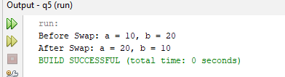

**Q-6: Print a number and find whether it is even or Odd.**

package q6;

public class Q6 {

public static void main (String [] args) {

int n = 9;

if (n % 2 == 0)

System.out.println(n + " is Even");

else

System.out.println(n + " is Odd");

}

}

**Output:**

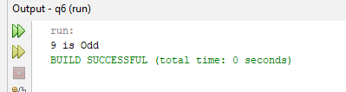

**Q-7: Print odd-even numbers from 1 to 10 using a for loop.**

package q7;

public class Q7 {

public static void main (String [] args) { for (int i = 1; i <= 10; i++) {

if (i % 2 == 0)

System.out.println(i + " is Even");

else

System.out.println(i + " is Odd");

}

}

}

**Output:**

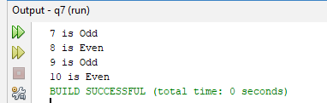

**Q-8: Print 1 to 10 using a while loop.**

package q8;

public class Q8{

public static void main(String[] args) {

int i = 1;

while (i <= 10) {

System.out.print(i + " "); i++;

}

}

}

**Output:**

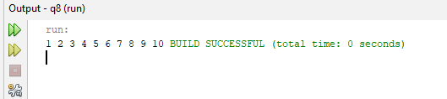

**Q-9: Print 1 to 10 using a do-while loop.**

package q9;

public class Q9 {

public static void main (String [] args) { int i = 1;

do {

System.out.print(i + " "); i++;

} while (i <= 10);

}

}

**Output:**

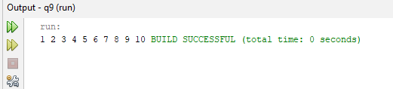

**Assignment-01**

**1. Write a java program to calculate and print the area of a triangle using its base and height.**

package areaoftriangle;

public class AreaOfTriangle {

public static void main(String[] args) {

double base = 30.0;

double height = 15.0;

double area = 0.5 * base * height;

System.out.println("The area of Triangle is: " + area);

}

}

**Output:**

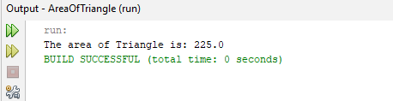

**2. Write a java program to check whether a given number is positive, negative, or zero and print the result**.

package numbercheck;

public class NumberCheck {

public static void main(String[] args) {

double number = 18.0;

if(number>0)

{

System.out.println(number+ " is posive.");

}

else if (number<0)

{

System.out.println(number + " is Negative.");

} else

System.out.println("The number is zero." +number);

}

}

**Output:**

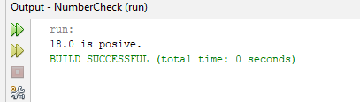

**3. Write a java program to find and print the smallest of three numbers.**

package smallestnumber;

public class SmallestNumber {

public static void main(String[] args) {

double num1 = 11.5;

double num2 = 21.7;

double num3 = 12.3;

double Smallest;

if (num1<=num2 && num1<=num3)

{

Smallest= num1;

}

else if(num2<=num1 && num2<=num3)

{

Smallest = num2;

} else

{

Smallest = num3;

}

System.out.println("The Smallest Number is: " +Smallest);

}

}

**Output:**

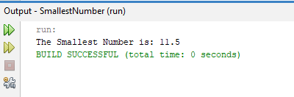

**LAB-03**

**Q-10: Print a right-side-down pyramid with 1 to 5 numbers.**

package q10;

public class Q10 {

public static void main(String[] args) { for (int i = 5; i >= 1; i--) {

for (int j = 1; j <= i; j++) {

System.out.print(j + " ");

}

System.out.println();

}

}

}

**Output:**

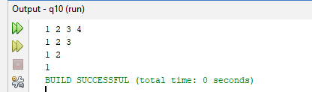

**Q-11: Print a right-side-down pyramid with 5 to 1 number.**

package q11;

public class Q11 {

public static void main (String [] args) { for (int i = 5; i >= 1; i--) {

for (int j = 5; j >= 6 - i; j--) {

System.out.print(j + " ");

}

System.out.println();

}

}

}

**Output:**

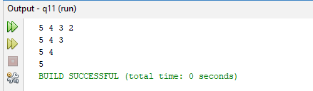

**Q-12: Print a right-side-down pyramid of stars with 4 rows.**

package q12;

public class Q12 {

public static void main(String[] args) { for (int i = 4; i >= 1; i--) {

for (int j = 1; j <= i; j++) {

System.out.print("* ");

}

System.out.println();

}

}

}

**Output:**

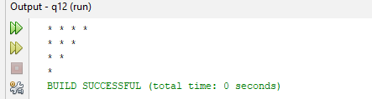

**Q-13: Print 'a' to 'z' and break in 'k' using a while loop.**

package q13;

public class Q13 {

public static void main (String [] args) { char ch = 'a';

while (ch <= 'z') {

if (ch == 'k') break; System.out.print(ch + " ");

ch++;

}

}

}

**Output:**

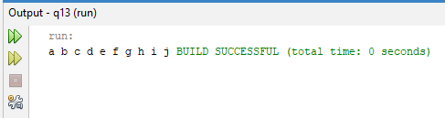

**Q-14: Print 'a' to 'z' and break in 'k' using a do-while loop.**

package14;

public class Q14{

public static void main (String[] args) { char ch = 'a';

do {

if (ch == 'k') break; System.out.print(ch + " ");

ch++;

} while (ch <= 'z');

}

}

**Output:**

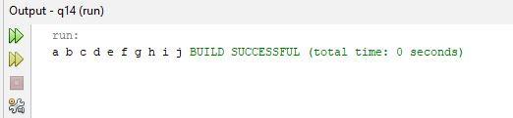

**Q-15: Print 'a' to 'z' and break in 'o' using a for loop.**

package q15; public class Q15 { public static void main(String[] args) { for (char ch = 'a'; ch <= 'z'; ch++) { if (ch == 'o') break;

System.out.print(ch + " ");

}

}

}

**Output:**

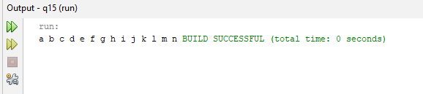

Assignment-02

**1.Write a java program to print the multiplication table of a given number using for loop.**

package prizeboard;

public class Prizeboard {

public static void main (String [] args)

{

int num = 39;

System.out.println("Quick Price Board: ");

for (int i=1; i<= 10; i++)

{

System.out.println(num+ "*" +i+ "="+ (num*i));

}

}

}

**Output:**

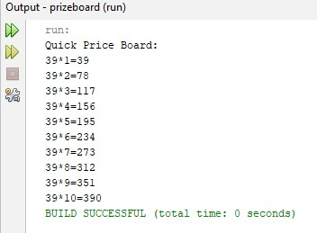

**2.Write a java program to display a right-angled triangle pattern of stars using nested while loops**.

package starsteps;

public class Starstep {

public static void main (String [] args)

{

int n = 5;

int i = 1; while (i<=n)

{

int j = 1; while (j<=i)

{

System.out.print("*"); j++;

}

System.out.println ();

i++;

}

}

}

**Output:**

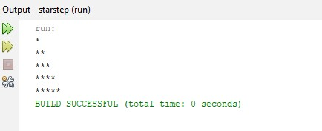

**3.Write a java program to print the first n odd numbers and their sum.**

package lanternparade;

public class Lanternparade {

public static void main (String [] args) { int n = 10;

int sum = 0;

int odd;

System.out.print("The Odd Numbers Are: "); for (int i=1; i<=n; i++){ odd = 2*i-1;

System.out.print(odd+ " "); sum = sum+odd;

}

System.out.println ();

System.out.println("The Sum of Odd Natural Number Upto " +n+ " Terms: " + sum); } }

**Output:**

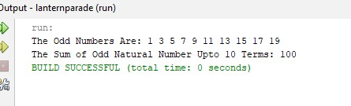

**4.Write a java program to calculate and print the factorial of a number using a for loop** package permutationvault;

public class Permutationvault {

public static void main (String [] args)

{

int n = 5;

long factorial = 1;

for (int i=1; i<=n; i++)

{

factorial = factorial*i;

}

System.out.println("The Museum Vault Key " +n+ " Unlocks in: " +factorial+ " Ways.")

}

}

**Output:**

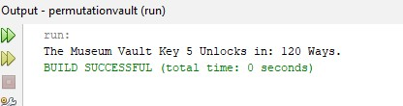

**LAB-04**

**Q-16: Check whether a value is prime or not.**

package q16;

public class Q16 {

public static void main(String[] args) {

int n = 36;

boolean isPrime = true;

if (n <= 1) {

isPrime = false;

}

else {

for (int i = 2; i <= n / 2; i++) {

if (n % i == 0) {

isPrime = false;

break;

}

}

}

if (isPrime)

System.out.println(n + " is a Prime number.");

else

System.out.println(n + " is NOT a Prime number.");

}

}

**Output:**

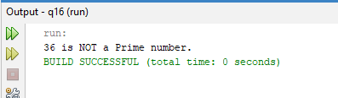

**Q-17: Library Class (Book Issue/Return OOP).**

package q17;

class Library {

String bookName; String authorName;

int quantity;

Library(String bookName, String authorName, int quantity) { this.bookName = bookName; this.authorName = authorName; this.quantity = quantity; }

void issueBook() { if (quantity > 0) { quantity--;

System.out.println("Book issued: " + bookName);

}

else

{

System.out.println("Sorry, book not available."); }

}

void returnBook() { quantity++;

System.out.println("Book returned: " + bookName);

} void display() {

System.out.println("Book: " + bookName + ", Author: " + authorName + ", Quantity: " + quantity);}

}

public class Q17{

public static void main(String[] args) {

Library b1 = new Library("Java Programming", "James Gosling", 3);

Library b2 = new Library("Python Basics", "Guido van Rossum", 2);

Library b3 = new Library("C++ Fundamentals", "Bjarne Stroustrup", 1);

b1.display(); b2.display(); b3.display();

b1.issueBook(); b1.display(); b1.returnBook(); b1.display();

}

}

**Output:**

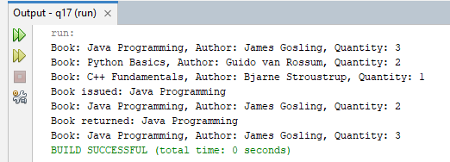

**Q-18: Palindrome Check (String).**

package q18;

public class Q18 {

public static void main(String[] args) {

String str = "hasi";

String rev = "";

for (int i = str.length() - 1; i >= 0; i--) { rev = rev + str.charAt(i)

}

if (str.equals(rev))

System.out.println(str + " is a Palindrome.");

else

System.out.println(str + " is NOT a Palindrome.");

}

}

**Output:**

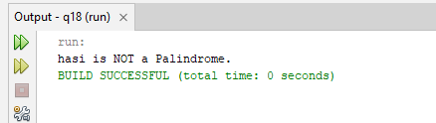

**Q-19: Armstrong Number Check.**

package q19;

public class Q19{

public static void main (String [] args) {

int num = 153,

sum = 0, temp, digit;

temp = num;

while (temp > 0) {

digit = temp % 10;

sum += digit * digit * digit;

temp /= 10;

}

if (num == sum)

System.out.println(num + " is an Armstrong number.");

else

System.out.println(num + " is NOT an Armstrong number.");

}

}

**Output:**

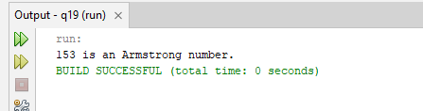

**Q-20: GCD & LCM of Two Numbers.**

package q20;

public class Q20 {

public static void main (String [] args) { int a = 80, b = 90, gcd = 1;

for (int i = 1; i <= a && i <= b; i++) { if (a % i == 0 && b % i == 0)

gcd = i;

}

int lcm = (a * b) / gcd;

System.out.println("GCD of " + a + " and " + b + " = " + gcd);

System.out.println("LCM of " + a + " and " + b + " = " + lcm);

}

}

**Output:**

